Chapter 7 Memory Management
Answers to Questions

7.1 Relocation, protection, sharing, logical organization, physical organization.

7.2 Typically, it is not possible for the programmer to know in advance which other programs will be resident in main memory at the time of execution of his or her program. In addition, we would like to be able to swap active processes in and out of main memory to maximize processor utilization by providing a large pool of ready processes to execute. In both these cases, the specific location of the process in main memory is unpredictable.

7.3 Because the location of a program in main memory is unpredictable, it is impossible to check absolute addresses at compile time to assure protection. Furthermore, most programming languages allow the dynamic calculation of addresses at run time, for example by computing an array subscript or a pointer into a data structure. Hence all memory references generated by a process must be checked at run time to ensure that they refer only to the memory space allocated to that process.

7.4 If a number of processes are executing the same program, it is advantageous to allow each process to access the same copy of the program rather than have its own separate copy. Also, processes that are cooperating on some task may need to share access to the same data structure.

7.5 By using unequal-size fixed partitions: 1. It is possible to provide one or two quite large partitions and still have a large number of partitions. The large partitions can allow the entire loading of large programs. 2. Internal fragmentation is reduced because a small program can be put into a small partition.

7.6 Internal fragmentation refers to the wasted space internal to a partition due to the fact that the block of data loaded is smaller than the partition. External fragmentation is a phenomenon associated with dynamic partitioning, and refers to the fact that a large number of small areas of main memory external to any partition accumulates.

7.7 A logical address is a reference to a memory location independent of the current assignment of data to memory; a translation must be made to a physical address before the memory access can be achieved. A relative address is a particular example of logical address, in which the address is expressed as a location relative to some known point, usually the beginning of the program. A physical address, or absolute address, is an actual location in main memory.

7.8 In a paging system, programs and data stored on disk or divided into equal, fixed-sized blocks called pages, and main memory is divided into blocks of the same size called frames. Exactly one page can fit in one frame.

7.9 An alternative way in which the user program can be subdivided is segmentation. In this case, the program and its associated data are divided into a number of segments. It is not required that all segments of all programs be of the same length, although there is a maximum segment length.

Answers to Problems
7.1 Here is a rough equivalence:

Relocation ≈ support modular programming
Protection ≈ process isolation; protection and access control
Sharing ≈ protection and access control
Logical Organization ≈ support of modular programming
Physical Organization ≈ long-term storage; automatic allocation and management

7.2 The number of partitions equals the number of bytes of main memory divided by the number of bytes in each partition: 224/216 = 28. Eight bits are needed to identify one of the 28 partitions.

7.3 Let s and h denote the average number of segments and holes, respectively. The probability that a given segment is followed by a hole in memory (and not by another segment) is 0.5, because deletions and creations are equally probable in equilibrium. so with s segments in memory, the average number of holes must be s/2. It is intuitively reasonable that the number of holes must be less than the number of segments because neighboring segments can be combined into a single hole on deletion.

7.4 By problem 7.3, we know that the average number of holes is s/2, where s is the number of resident segments. Regardless of fit strategy, in equilibrium, the average search length is s/4.

7.5 A criticism of the best fit algorithm is that the space remaining after allocating a block of the required size is so small that in general it is of no real use. The worst fit algorithm maximizes the chance that the free space left after a placement will be large enough to satisfy another request, thus minimizing the frequency of compaction. The disadvantage of this approach is that the largest blocks are allocated first; therefore a request for a large area is more likely to fail.

7.6 a. The 40 M block fits into the second hole, with a starting address of 80M. The 20M block fits into the first hole, with a starting address of 20M. The 10M block is placed at location 120M.

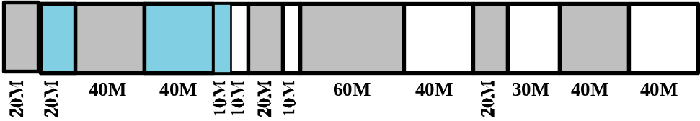

b. The three starting addresses are 230M, 20M, and 160M, for the 40M, 20M, and 10M blocks, respectively.

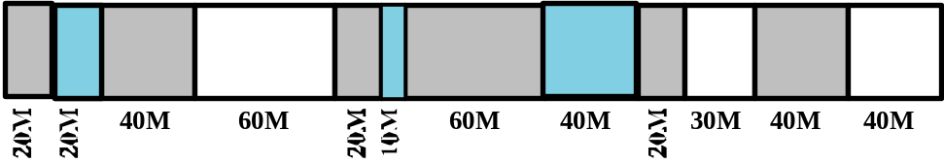

c. The three starting addresses are 80M, 120M, and 160M, for the 40M, 20M, and 10M blocks, respectively.

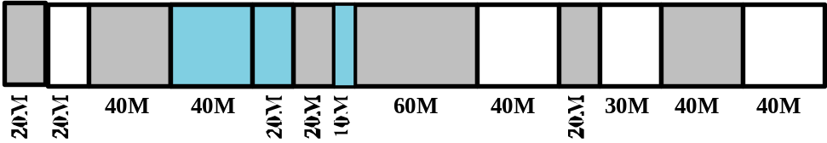

d. The three starting addresses are 80M, 230M, and 360M, for the 40M, 20M, and 10M blocks, respectively.

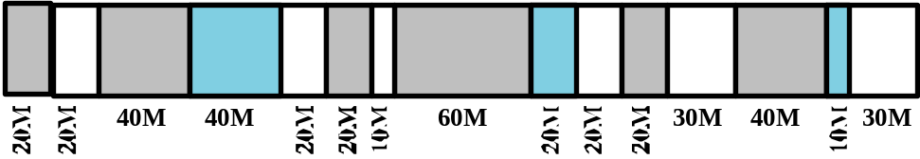

7.7 a.

Request 70 | A | 128 |  | 256 |  | 512
Request 35 | A | B | 64 | 256 |  | 512
Request 80 | A | B | 64 | C | 128 | 512
Return A | 128 | B | 64 | C | 128 | 512
Request 60 | 128 | B | D | C | 128 | 512
Return B | 128 | 64 | D | C | 128 | 512
Return D | 256 |  |  | C | 128 | 512
Return C | 1024

b.
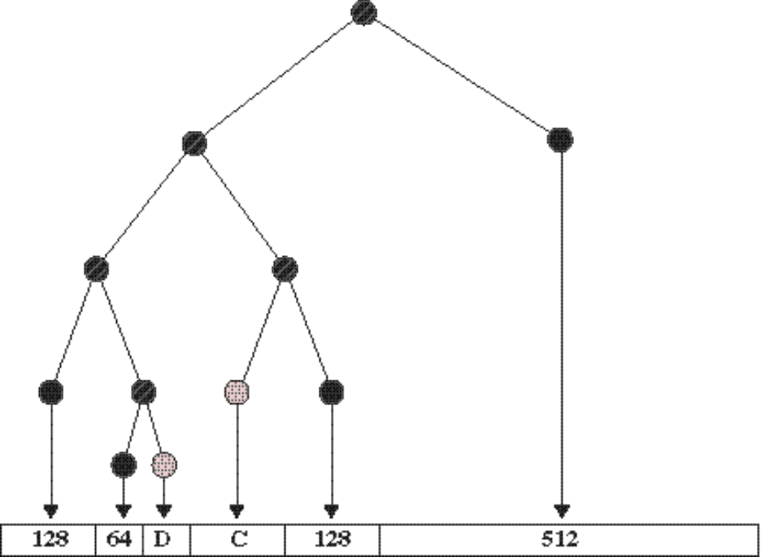

7.8 a. 011011110100
b. 011011100000

7.9

7.10 a. Yes, the block sizes could satisfy Fn = Fn-1 + Fn-2.
b. This scheme offers more block sizes than a binary buddy system, and so has the potential for less internal fragmentation, but can cause additional external fragmentation because many uselessly small blocks are created.

7.11 The use of absolute addresses reduces the number of times that dynamic address translation has to be done. However, we wish the program to be relocatable. Therefore, it might be preferable to use relative addresses in the instruction register. Alternatively, the address in the instruction register can be converted to relative when a process is swapped out of memory.

7.12 a. The number of bytes in the logical address space is (216 pages) × (210 bytes/page) = 226 bytes. Therefore, 26 bits are required for the logical address.
b. A frame is the same size as a page, 210 bytes.
c. The number of frames in main memory is (232 bytes of main memory)/(210 bytes/frame) = 222 frames. So 22 bits is needed to specify the frame.
d. There is one entry for each page in the logical address space. Therefore there are 216 entries.
e. In addition to the valid/invalid bit, 22 bits are needed to specify the frame location in main memory, for a total of 23 bits.

7.13 The relationship is a = pz + w, 0 ≤ w < z, which can be stated as:
p = ⎣a/z⎦, the integer part of a/z.
w = Rz(a), the remainder obtained in dividing a by z.

7.14 a. Segment 0 starts at location 660. With the offset, we have a physical address of 660 + 198 = 858
b. 222 + 156 = 378
c. Segment 1 has a length of 422 bytes, so this address triggers a segment fault.
d. 996 + 444 = 1440
e. 660 + 222 = 882

7.15 a. Observe that a reference occurs to some segment in memory each time unit, and that one segment is deleted every t references. Because the system is in equilibrium, a new segment must be inserted every t references; therefore, the rate of the boundary's movement is s/t words per unit time. The system's operation time t0 is then the time required for the boundary to cross the hole, i.e., t0 = fmr/s, where m = size of memory. The compaction operation requires two memory references—a fetch and a store—plus overhead for each of the (1 – f)m words to be moved, i.e., the compaction time tc is at least 2(1 – f)m. The fraction F of the time spent compacting is F = 1 – t0/(t0 + tc), which reduces to the expression given.
b. k = (t/2s) – 1 = 9; F ≥ (1 – 0.2)/(1 + 1.8) = 0.29

